**Student Name : Uzma Ejaz**

**Problem Statement:**

**Task: 1** Load the Customers and Sales CSV files from the following link: (Provide Screenshot)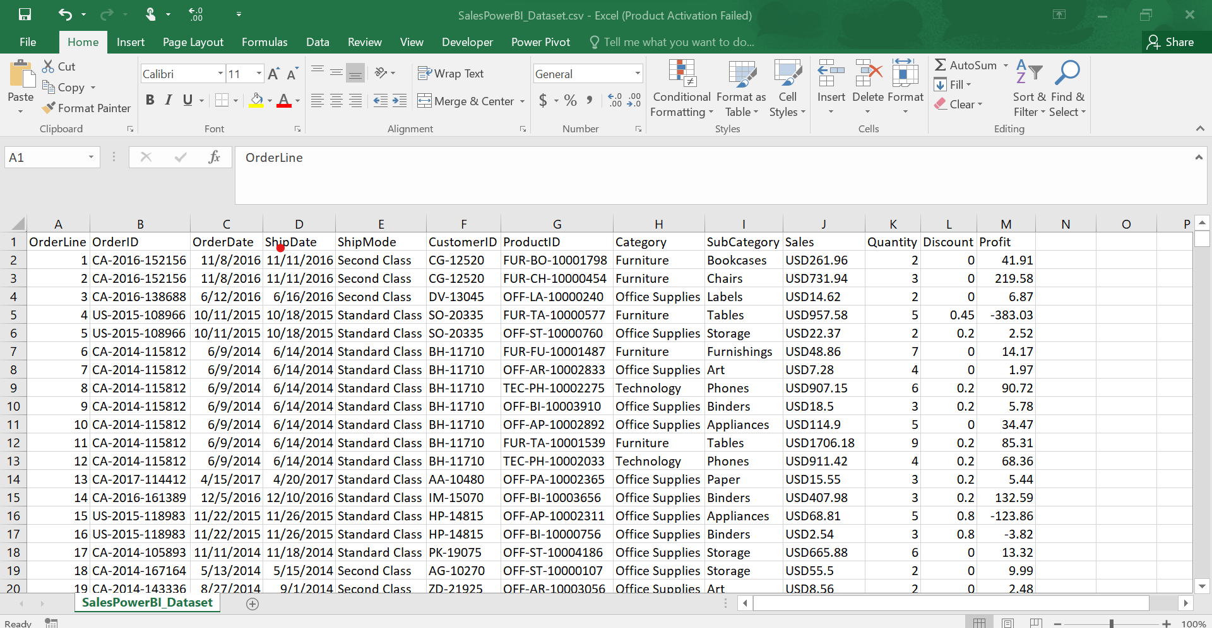

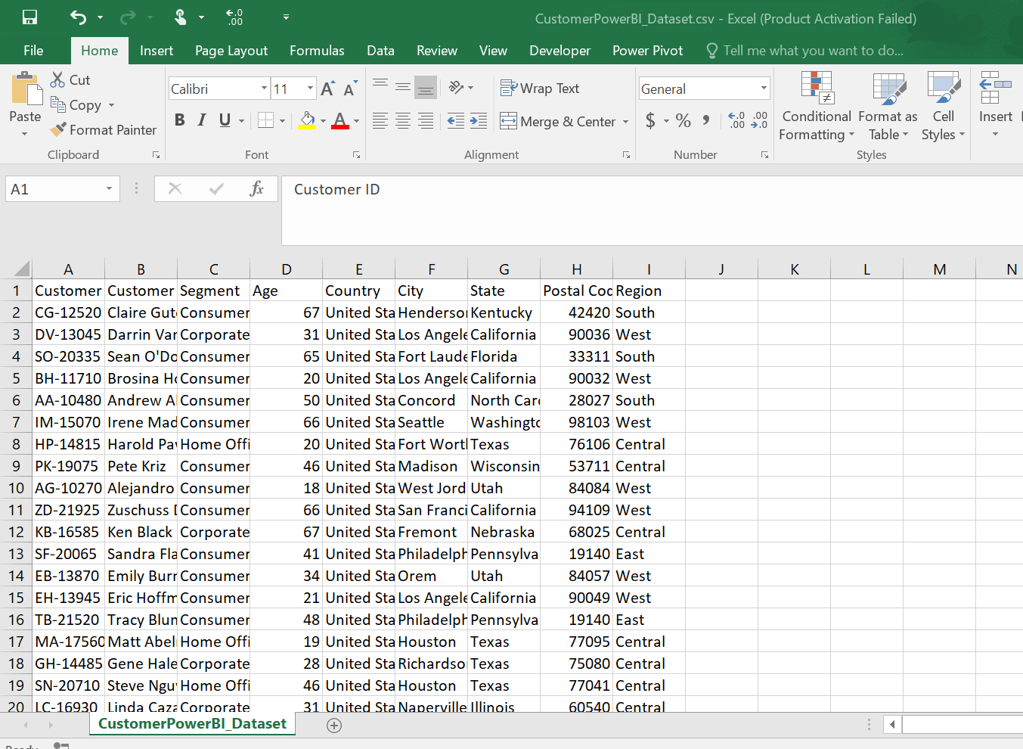

**Task: 2** Split and rename columns “Customer Name” into “First Name” and “Last Name” in the Power BI.(Provide Screenshot)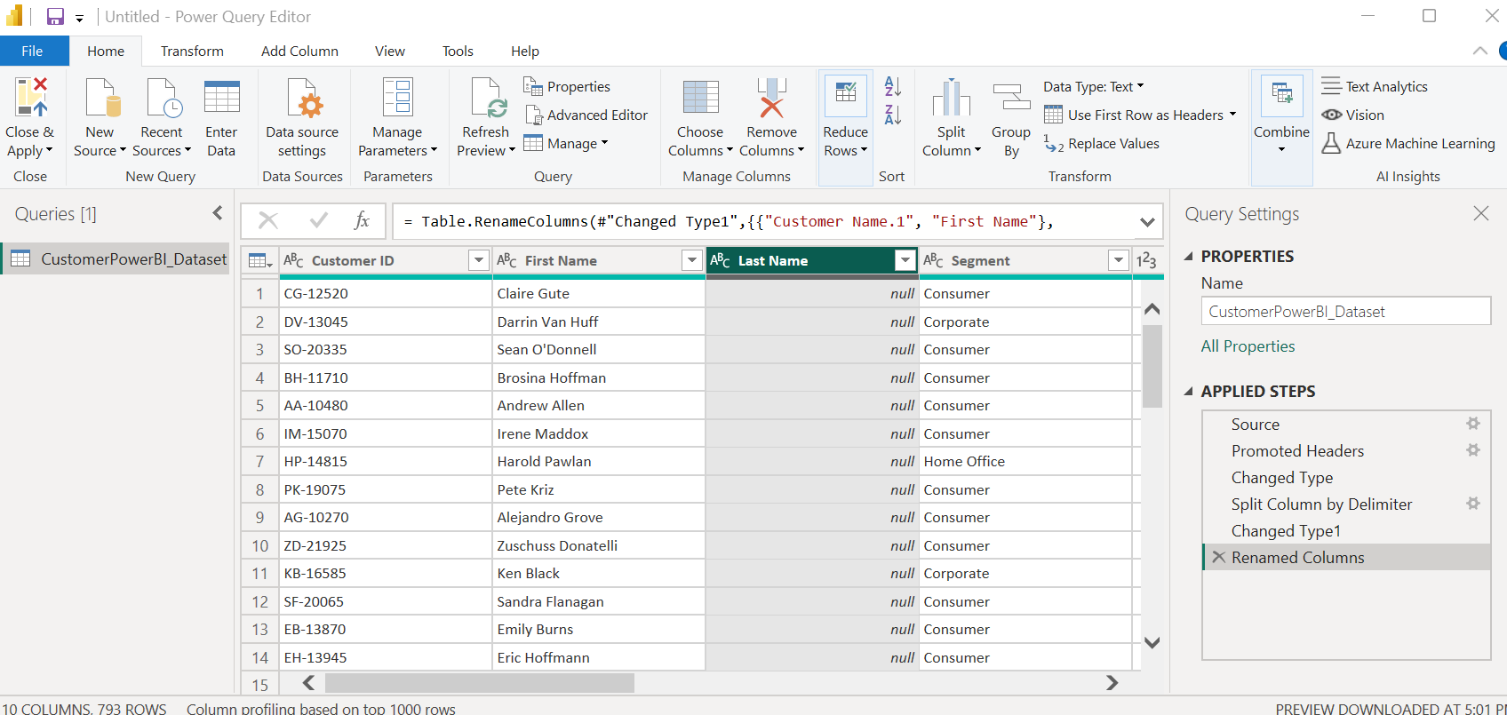

**Task: 3** Add conditional column on “Age” column and convert age into three categories like (Young: 17-30), (Adult:31-45) and (Senior: above >45). (Provide Screenshot)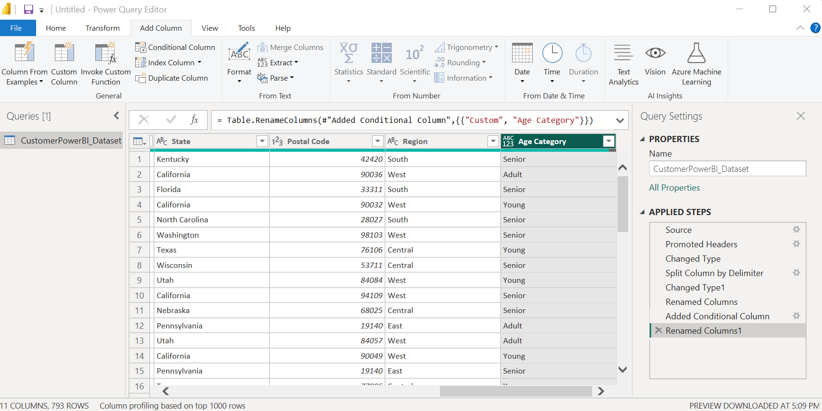

**Task: 4** Remove column “Age” and “Region” from the “Customer” data and change data types of “Postalcode” column from number to text. (Provide Screenshot)